COME AND JOIN US

Our friendly group has been part of the social scene of St Paul’s for years - we meet from 10.15 until about noon every Tuesday in our small hall

We invite anyone in the local community to join us on a regular or occasional basis & share in friendship.

We have a varied programme (see overleaf) with talks, craft sessions and, outings, and we also support church activities - open days, lunches and other welcoming and community events.

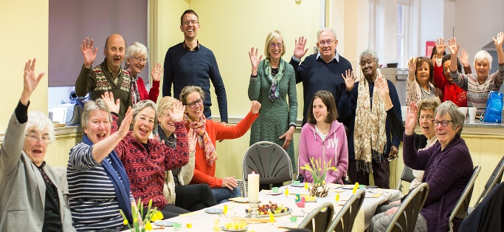

Membership of St. Paul’s Guild is open to all. New members, men and women, are welcome throughout the year. The annual subscription is £10 payable in September plus a contribution for refreshments when we have external speakers.

Guests are welcomed for a voluntary charge of £2.00 to cover costs

HOW TO FIND US
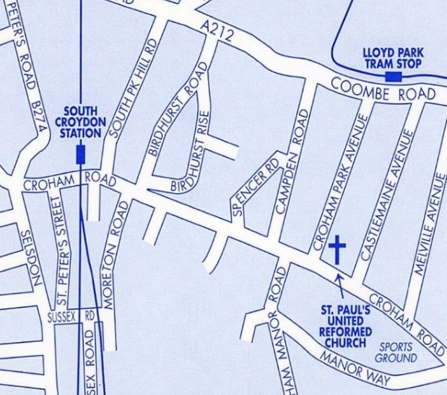

By Bus: Nos. 64; 433 from Selsdon or East Croydon; Stop called
‘St Paul’s United Reformed Church’ is outside

By Tram: Lloyd Park stop is 7 mins walk

By Train: South Croydon is 9 mins walk.
From East Croydon, take tram towards New Addington or bus above for Selsdon/Addington

By Car: We have parking for about 12 cars, or in nearby streets

St Paul’s
United Reformed Church
Croham Park Avenue
South Croydon
CR2 7HF
‘All are welcome’

Tuesday Guild
at St Paul’s
United Reformed Church

Programme – spring 2022 V2

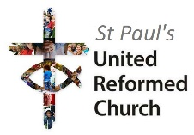
www.stpaulsurc.org.uk
www.facebook.com/stpaulsurc

Croham Road
corner of Croham Park Avenue
South Croydon CR2 7HF
07971 068887 –Sue - Church Secretary

St Paul’s Guild Programme 2022
Talks start at 10.30. Refreshments from 10.15.
January 2022
4th Our Welcome Meeting – Presentation of the programme, Accounts, New Year Resolutions.
11th Cllr Jason Perry talks about ‘How the council works’.
18th Bea Pollard talks about ‘Robert Burns’.
25th Craft and Natter
February 2022
1st Ruth Markus talks about ‘The new AMECA Maternity Unit, in rural Malawi’.
8th Ray Wheeler talks about ‘Genealogy’.
15th Jan King speaks about ‘Greece part II’.
22nd Craft and Natter
March 2022
1st Rev Nadine Snyman on ‘Your Synod Green Apostle’.
8th Police / neighbourhood watch – staying safe, by Joseph Nelson
15th Hearing Dogs for the Deaf or Update on International Needs
22nd Craft and Natter
29th Eleanor Redshaw talks about ‘Lemurs, Volcanoes and Giant Tortoises - an Indian Ocean Odyssey’.
April 2022
5th Easter Miscellany
12th Break for Easter
19th Annual General Meeting
26th Craft and Natter
May 2022
3rd Outing to the Horniman Museum - tbc

Further copies of the programme are available from the Church Secretary, Sue Eardley, on 0797168887 or Secretary@StPaulsURC.org.uk
Or see our website or Facebook pages for up-to date details www.stpaulsurc.org.uk or www.facebook.com/stpaulsurc

